System:

A system is any object that has one or more inputs and outputs

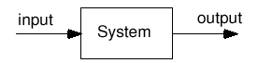

A simple instrument model (Open loop)
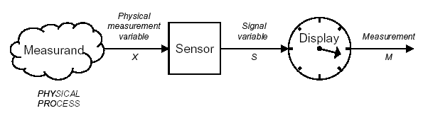
A observable variable X is obtained from the measurand
- X is related to the measurand in some KNOWN way (i.e., measuring mass)
- The sensor generates a signal variable that can be manipulated:
- Processed, transmitted or displayed
- In the example above the signal is passed to a display, where a
- measurement can be taken

Closed loop system:
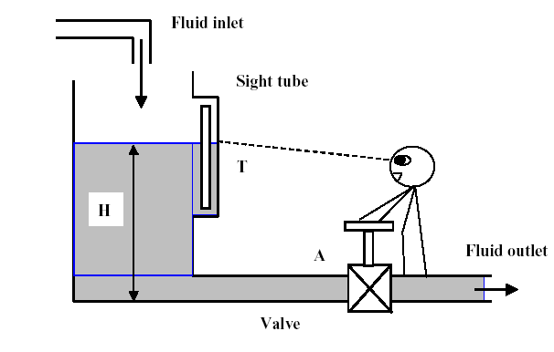

Manual Process Control

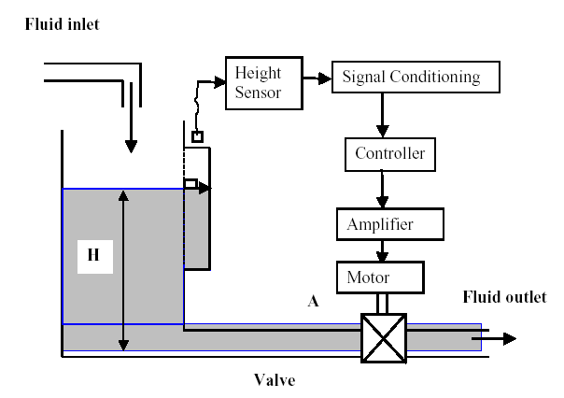
Physical Diagram

The basic variables of feedback control are shown in Fig. (Closed loop)

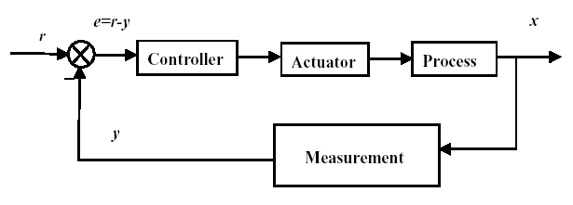
Block Diagram of Process Control

The main parts of closed loop simple process control are:

- Reference value
- Controller ( analog /digital)
- Actuator
- Process or plant (the controlled environment)
- Measurement (sensor)
- Error detection and calculation circuit ( analog /digital)

Definitions:
Some common terms in system design, measurement and process control:

Error
the most important quanity in control systems is the error. When used to describe the results of a measurment, error is the deference between the actual value of a variable and the measured indication of its value. In that case, the accuracy of the measurment system places bounds on the possible error.
When used for a control variable in a control system, error is the defference between the measurd value of the variable and the desired value-that is, the reference or setpoint value.

Blok Definitions

Systems are often described in terms of blocks. One block represents the measurment, another controller, and so on. In order to work effectively in control systems, one must understand the terms and expressions used to describe the characteristics of a block. Figur ....shows a block that has an input of some variable, x(t), and an output of another variable, y(t). This model will be used in the following paragraphs to define the characteristics of the block.
T(x, y, t)
x(t)
y(t)

Transfer function (system or device)

The transfer function, T(x, y, t), describes the relationship between the input and output for the block. The transfer function is often described in two parts, the static part and the dynamic part. The static transfer function describes the input/output relationship when the input is not changing in time. The dynamic transfer function describes the input/output relationship when there is time be presented in the form of equations, tables, or graphs.

Measurement and device accuracy

this term is used to specify the maximum overall error to be expected from a device.
Accuracy can be measured in terms of

1. Measured variable; the accuracy is ± 2ºC in some tempraeture measurment. Thus, there would be an uncertainty of ± 2ºC in any value of tempreature measured.

2. Percentage of the instrument full-scale (FS) reading. Thus, an accuracy of ± 0.5% FS in a 5-V full-scale range meter would mean the inaccuracy or uncertainty in any in any measurment is ± 0.025 V.

3. Percentage of instrument span-that is , percentage of the rang of instrument measurment capability. Thus, for a device measuring ± 3% of span for a 20 to 50 psi rang of pressure, the accuracy would be (± 0.03)(50 – 20) = c 0.9psi.

4. Percentage of the actual reading. Thus, for a ±2% of reading voltmeter, we would have an inaccuracy of ±0.04 V for a reading of 2 V.
Example:
A temperature sensor has a span of 20º – 250ºC. A measurment results in a value of 55ºC for the temperature. Specify the error if the accuracy is (a) ±0.5% FS, (b) ±0.75% of span, and (c) ±0.8% of reading. What is the possible temperature in each case?
Solution

Using the given definitions, we find
a. Error = (±0.005)(250ºC) = ±1.25ºC. Thus , the actual temprature is in the rang of 53.75º to 56.25ºC.
b. Error = (±0.0075)(250 – 20)ºC = ±1.725ºC. Thus, the actual temprature is in the range of 53.275º to 56.725ºC.
c. Error = (±0.008)(55ºC) = ±0.44ºC. Thus, the temprature is in the range of 54.56º to 55.44ºC.

A temprature sensor has a transfer function of 5 mV/ºC with an accuracy of ±1. Find the possible range of the transfer function.
Solution
The transfer function range will be (±0.01)(5 mV/ºC) = ±0.05 mV/ºC. Thus, the range is 4.95 to 5.05 mV/^{oC.}
Example:
Suppose a reading of 27.5 mV results from the sensor used in last example. Find the temperature thet could provide this reading.
Solution
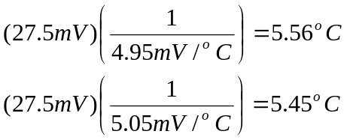Because the rang of transfer function is 4.95 to 5.05 mV/ºC, the possible temperature
valuse that could be inferred from a reading of 27.5 mV are
Thus, we can be certain only that the temperature is between 5.45ºC and 5.56ºC.

System Accuracy

Often, one must consider the overall accuracy of many elements in a process-control loop to represent a process variable. Generally, the best way to do this is to express the accuracy of each element in terms of the transfer function. For example, suppose we have a process with tow transfer functions that act on the dynamic variable to produce an output voltage as shown in Figure below.

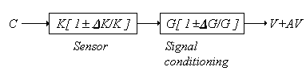

We can describe the output as
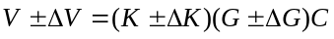where V = output voltage
± ΔV= uncertainly in output voltage
K,G = nominal transfer function
ΔK, ΔG = uncertainties in transfer functions
C = dynamic variable
From Equation above, we can find the output uncertainly to be
ΔV = ± GC ΔK ± KC ΔG ± ΔK ΔGC (1.4)
equation (1.4) can be further simplified by noting that nominal output is V = KGC
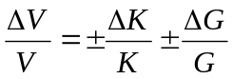where
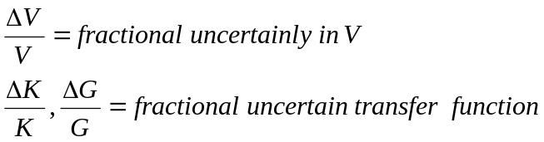We can best interpret Equation above as stating that the worst-case accuracy would be the sum of the uncertainties of each transfer function.
From a statiscal point of view, it is more realistic to express the overall system accuracy as the root-mean-square (rms) of the individual element accuracy. This will give system accuracy better than worst case but more likely to actual response. This is found from the relation
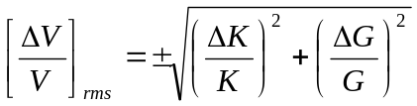
Example Find the system accuracy of a flow process if the transducer transfer function is 10mV/(m³/s) ± 1.5% and the signal-conditioning system-transfer function is 2mA/mV ±0.05%.
Solution
Here we have a direct application of
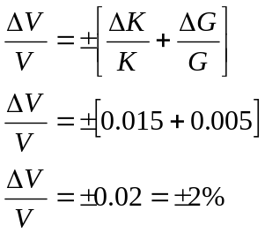
So that net transfer function is 20 mA/(m³/s) ± 2%. If we use the more statistically correct rms approach, the system accuarcy would be
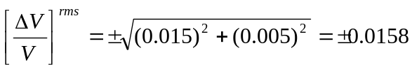 So the accuracy is about ± 1.6%.

This term is used to specify the maximum overall error to be expected from a device.

Sensitivity
Sensitivity is a measure of the change in output of an instrument for a change in input. Generally speaking, high sensitivity is desirable in an instrument because a large change in output for a small change in input implies that a measurment may be taken easily. Sensitivity must be evaluated together with other parameters, such as linearity of output to input, rang, and accurancy. The value of the sensitivity is generally indicated by the transfer function. Thuse, when a tempreature transducer output 5 mV per degree Celsius, the sensitivity is 5mV/º C.

Hysteresis and Reproducibility

Frequently, an instrument will not have the same output value for a given input in repeated trials. Such variation can be due to inherent uncertainties that imply a limil on reproducibility of device. The variation is random from measurment and is not predictable.
A similar effect is related to the history of a particular measurment taken with an instrument. In this case, a different reading results for a specific input, depending on whether the input value is approached from higher or lower values. This effect called hysteresis. Hysteresis is a predictable error resulting from differences in the transfer function as the input variable increases or decreases. Many physical systems naturally exhibit hysteresis. As shown in figure hysteresis is maximum deviation between curve A and B.

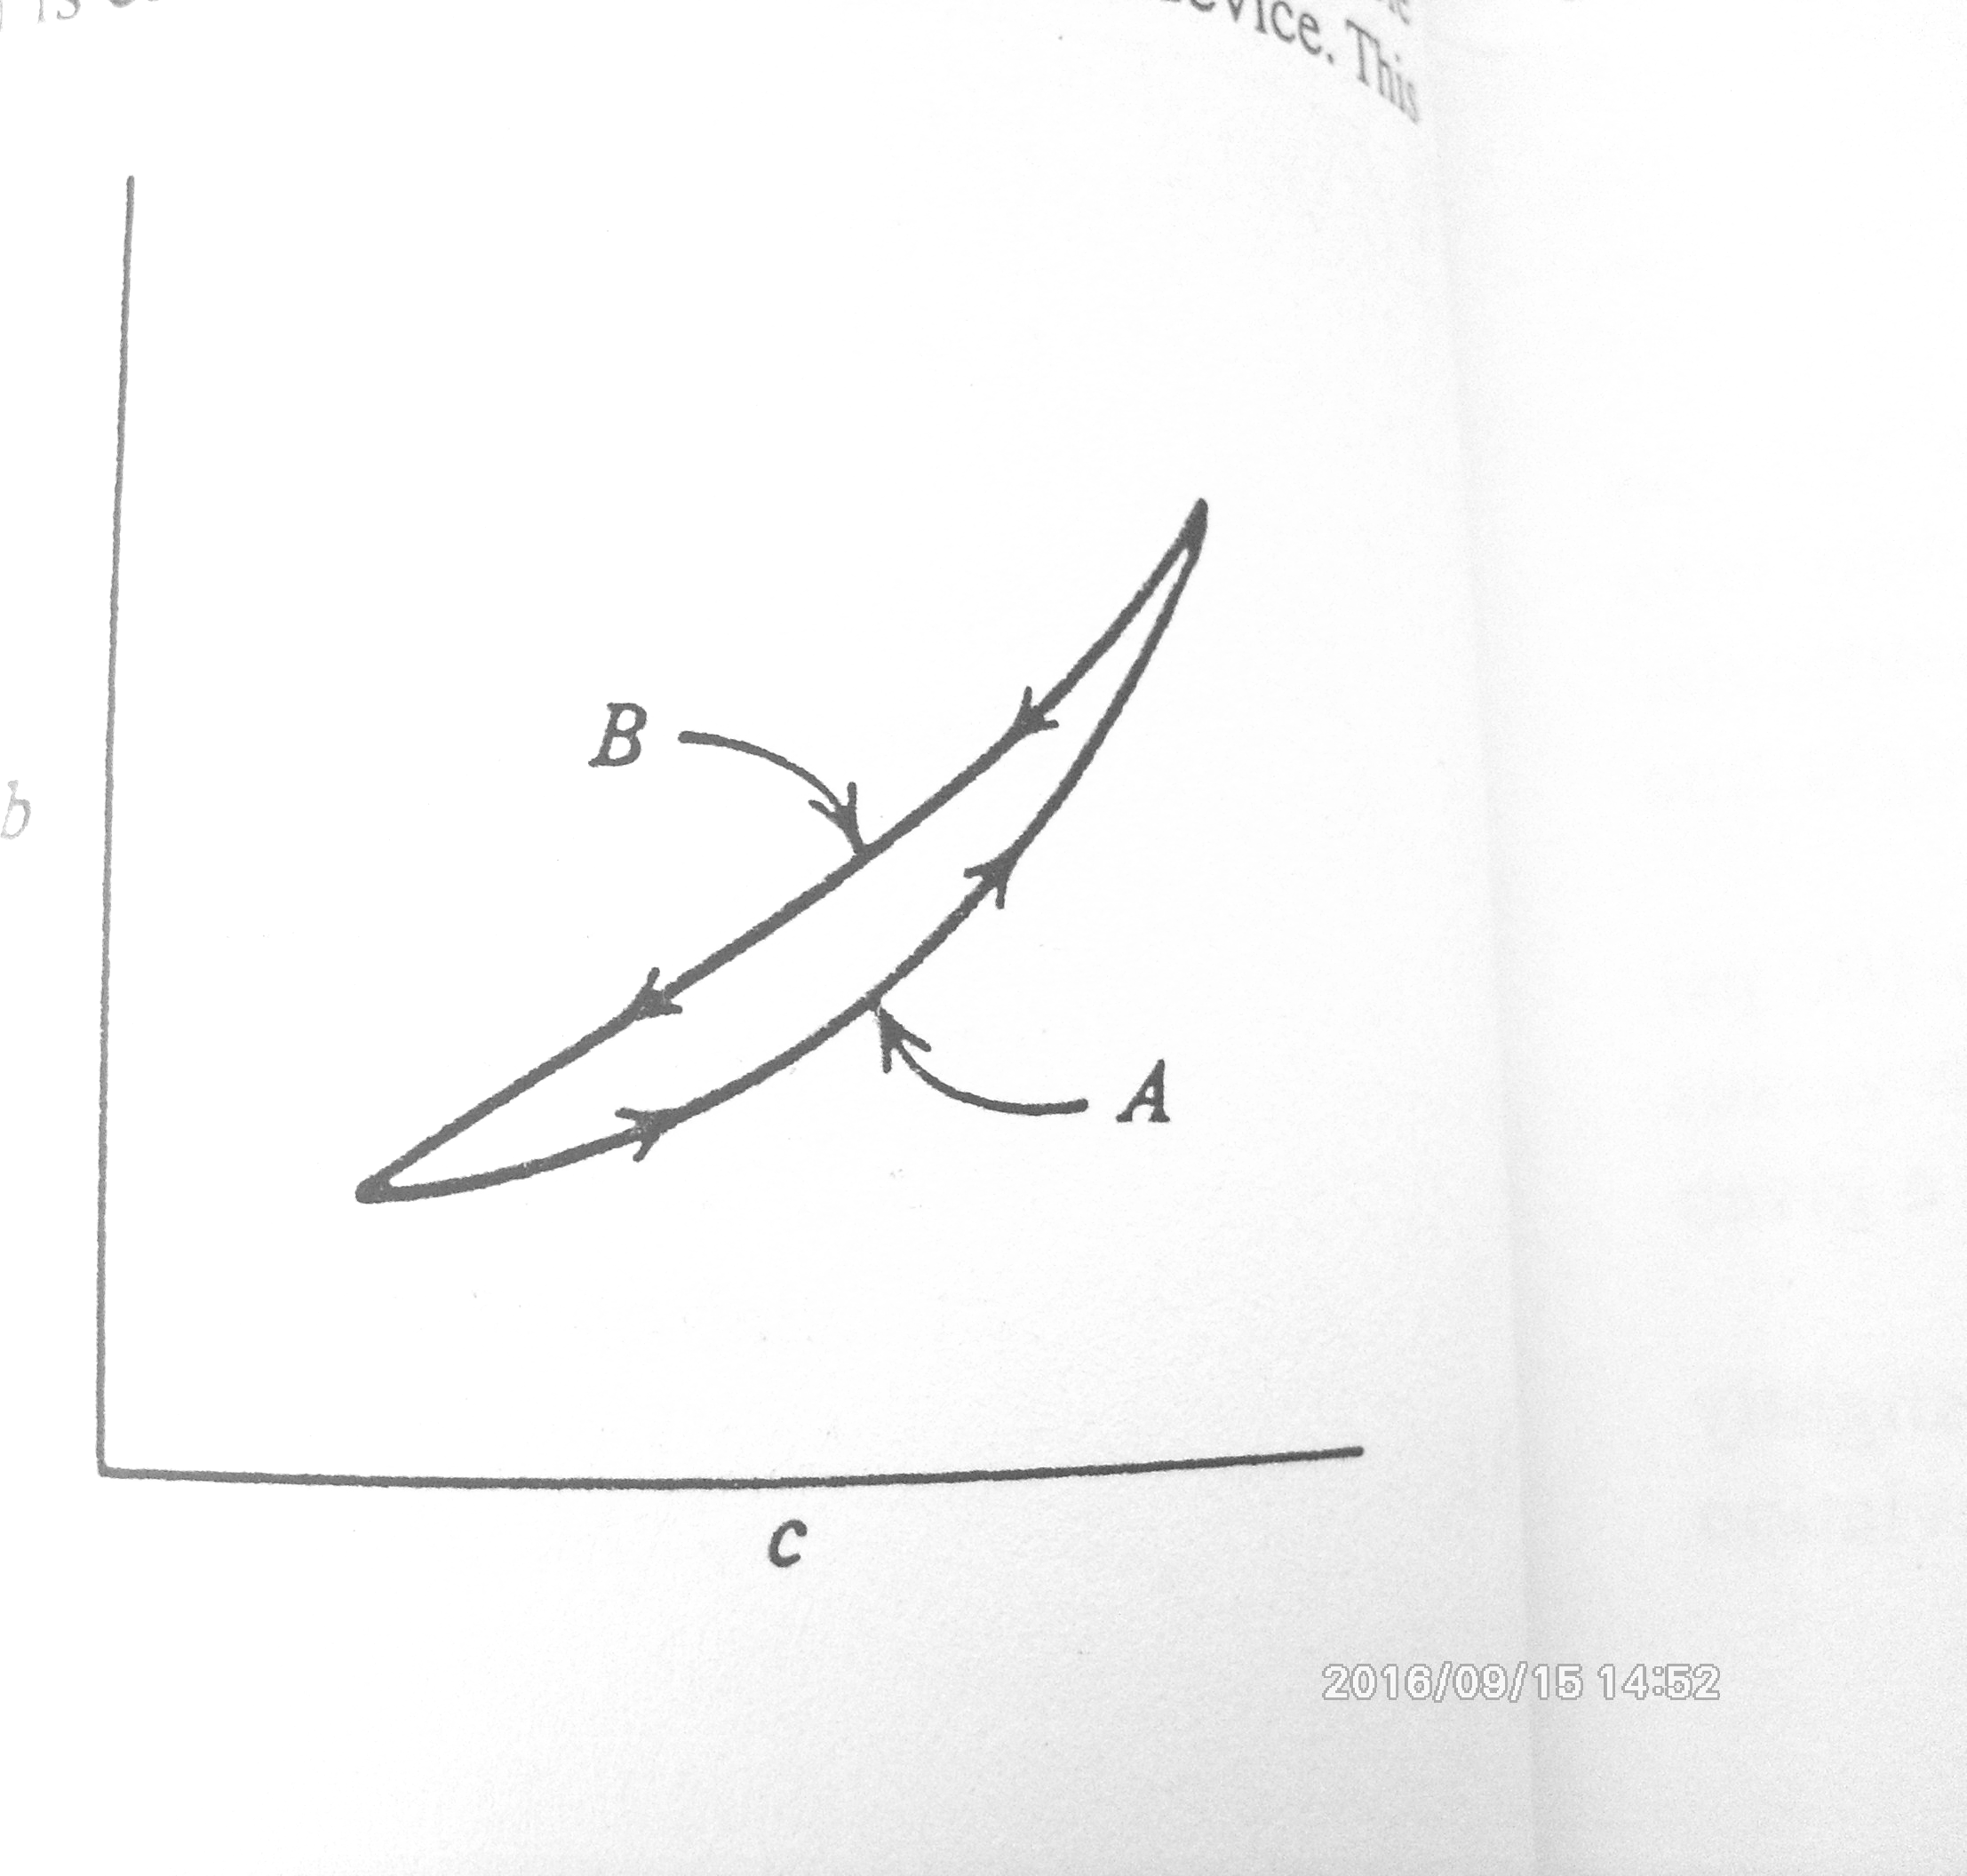

Measurement resolution

Inherent in many measurment devices is a minimum measurable value of the input variable. Such a specification is called the resolution of the device. This characteristic of the instrument can be changed only by redesign.

A force sensor measures a range of 0 to 150 N with a resolution of 0.1% FS. Find the smallest change in force that can be measured.
(0.001)(150N) = 0.15N
a sensor has a transfer function of 5 mV/ºC. Find the required voltage of the signal conditioning if a temprature resolution of 0.2ºC is required.
A temperature change of 0.2ºC will result in a voltage change of
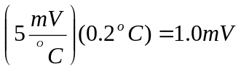
Linearity
In both sensor and signal conditioning, output is represented in some functional realationship to the input. The only situation is that this realationship be unique; able. For simplicity of design, a linear relationship between input and output is highly desirable. When a linear relationship exists, a straight-line equition can be used to related the measured variable and measurment output.
c_{m} = mc + c₀

c = variable to be measured
m = slope of straight line
c₀ = offset or intercept of stright line
c_{m} = output of measurment

A sensor resistance change linearly from 100 to 180 Ω as temperature changes from 20º to 120ºC. fined a linear equation relating resistance and temperature.
R = mT + R₀
100Ω = (120ºCm + R₀)
180Ω = (120ºCm + R₀)
80Ω = (100ºC)m or m =0.8Ω/ºC
100Ω = (20ºC)(0.8Ω/ºC) + R₀
R₀ =84Ω
R = 0.8T + 84

Example:
Suppose the temperature range 20º to 120ºC is linearly represented by the standard current rang of 4 to 20 mA. What current will result from 66ºC ? What temperature does 6.5 mA represent ?
The easiest way to solve this kind of problem is to develop a linear equation between temperature and current.
I = mT+I₀

4mA = (20ºC)m + I₀

20mA = (120ºC)m + I₀

16mA = (100º C)m

I₀ = 4mA – (20ºC) (0.16 mA/ºC)

I₀ = 0.8 mA

I = (0.16 mA/ºC)T + 0.8 mA

I = (0.16 mA/ºC)66ºC + 0.8 mA = 11.36 mA

6.5 mA = (0.16 mA/ºC)T + 0.8 mA

T = 35.6ºC

SENSORS

Sensor is a device that responds to a physical or chemical stimulus and transmits a
resulting impulse as for measurement or operating a control.
Another words, sensor is a device that produces an output signal for the purpose of sensing a physical phenomenon.

TRANSDUCERS

Transducers are devices that convert one form of energy into another. Usually we use them to covert various physical parameters to and from electrical signals. This is because a microprocessor or microcontroller can conveniently measure electrical signals via an ADC and output electrical signals via a DAC.

Another words, transducer is a device that converts a signal from one physical form to a corresponding signal that has a different form.

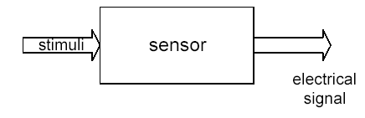

Sensor Applications
- Monitoring of processes and operations
- Control of processes and operations
- Experimental engineering analysis
- Environment and safety measurement
Sensor are Used to measure physical quantities such as: - position - velocity, - temperature, - sound, - light, etc.

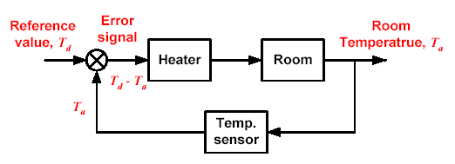
Sensor in temperature measurement

Sensor classification schemes

Classification Sensor Type

Signal characteristics Analog, Digital

Power requirements Active, Passive

Subject of measure Electrical, Mechanical, Optical, Thermal, Acoustic

Sensor Performance Characteristics (Static, Dynamyic)

Dynamyic characteristics: The sensor can be tested by a step response where the sensor output is recorded for a sudden change of the physical variable.

Static characteristics: | Dynamyic characteristics:
- Accuracy  - Resolution  - Linearity  - Full scale input (input span)  - Full scale output (output span  - Sensitivity  - Hysteresis  - Repeatability  - Transfer Function (degree, linear or non-linear)  - Bandwidth | - Rise time  - Time constant  - Cut off frequency  - Repeatability  - Linearity  - Dead time or Time delay  - Settling time

Transfer Function:

It is the functional relationship between physical input signal and electrical output signal. Usually, this relationship is represented, as a graph showing the relationship between the input and output signal, and the details of this relationship may constitute a complete description of the sensor characteristics. For expensive sensors, which are individually calibrated, this might take the form of the certified calibration curve.

Sensitivity:

Sensitivity: Incremental ratio of the output electrical signal ( y) to the desired inputsignal (x). The sensitivity is defined in terms of the relationship between input physical signal and output electrical signal. The sensitivity is generally the ratio between a small change in electrical signal to a small change in physical signal. As such, it may be expressed as the derivative of the transfer function with respect to the physical signal. Typical units: Volts/Kelvin. A thermometer would have "high sensitivity" if a small temperature change resulted in a large voltage change.
Ex. A movement of 0.001 mm causes an output voltage of 0.02 volts.
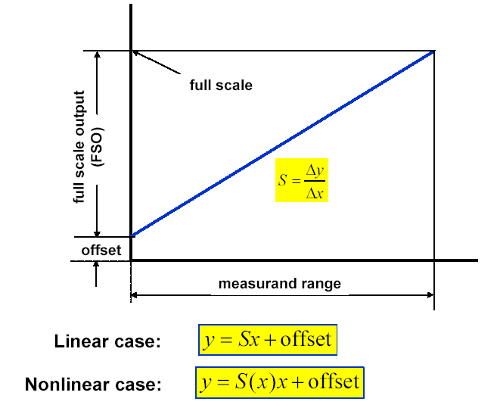
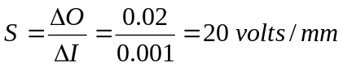
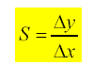

Accuracy:

Generally defined as the largest expected error between actual and ideal output signals. Typical Units: Kelvin. Sometimes this is quoted as a fraction of the full-scale output. For example, a thermometer might be guaranteed accurate to within 5% of FSO (Full-Scale Output)
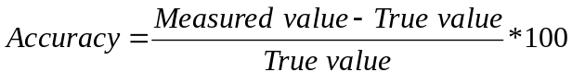

Nonlinearity (often called Linearity):

It is the maximum deviation from a linear transfer function over the specified dynamic range. There are several measures of this error. The most common compares the actual transfer function with the `best straight line', which lies midway between the two parallel lines which encompasses the entire transfer function over the specified dynamic range of the device. This choice of comparison method is popular because it makes most sensors look the best.

Resolution:
The smallest increment in the value of the measure and that results in a detectable increment in the output. It is expressed in the percentage of the measurand range
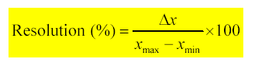
Repeatability (precision): The maximum deviation from the average of
repeated measurements of the same static variable.

Bandwidth:

All sensors have finite response times to an instantaneous change in physical signal. In addition, many sensors have decay times, which would represent the time after a step change in physical signal for the sensor output to decay to its original value. The reciprocal of these times correspond to the upper and lower cutoff frequencies, respectively. The bandwidth of a sensor is the frequency range between these two frequencies.

SENSORS (Examples)
Temperature sensors
There are three common type sensors:
- thermo-elements
- resistance temperature detectors (RTD)
- thermistors

Thermo-element (thermocouple)
The working principle is based on the Seebeck discovery. When two wires made from different metals are joint at both ends and one end is heated, there is a continuous current, which flows into the thermoelectric circuit. If this circuit is broken the voltage is a function of the junction temperature.

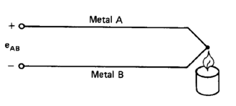
Characteristic:
Thermocouples have non-linear characteristics, which is given in a table or by
approximating polynomial. Thermocouples are cheap, have small heat capacity, are robust and have wide temperature rate.

Resistance Temperature Detectors (RTD)
Resistivity of metals depends on temperature (Humphry Davy, 1821). In 1871
William Siemens built the first resistance thermometer using platinum.
The resistance R is an almost linear function of temperature from the reference
Temperature in order to sense the change in resistance we have to pass current through the sensor. The sensitivity is very small for RTD and any current if used to sense the resistance will heat up the sensor thus changing the measurement. The RTD is supplied by a current source and a digital voltmeter measures voltage drop across the resistor.

Thermistor
A thermistor is made of semiconductor material having negative temperature coefficient and large sensitivity. Characteristic of thermistor is shown in figure

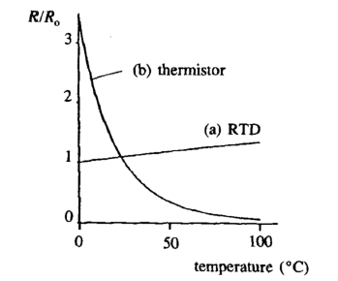
Its resistance depends on temperature in a non-linear fashion:

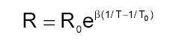
The thermistor is not an accurate temperature sensor. It is mainly used for measuring small temperature changes.

Hall Effect Sensor: When a magnetic field is applied to a conductor
with current flowing through it, a voltage drop across the conductor is generated.

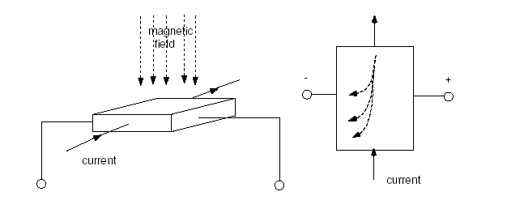

Applications of Hall effect sensors
- analog proximity sensor
- limit switch
- Fluid level sensor
- Measuring Blood Flow

Magnetic Reed Switch

- Hall Effect: Physics and Principles
- Applications of the Hall Effect in
- Sensor systems
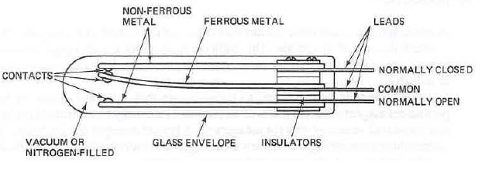
Magnetic Reed Switch (Operation)

The glass bulb is either evacuated or contains an inert gas; e.g., nitrogen. The movable contact is “oil-canned”; a built-in snap action takes place when the contact is moved slightly.
When a magnet is brought close to the sensor, the common contact is attracted toward the magnet, causing it to snap into its new position against the other contact. When the magnetic field is removed, the middle reed snaps back into its original position. It can be used as a proximity switch.

Position and Velocity Measurements sensors:
- Tachometer: produces a voltage proportional to velocity (usually rotational velocity)
- Potentiometer: produces a voltage proportional to distance from a reference point
- Optical Encoder (Often used for digital position and velocity measurement)

MECHANICAL SENSORS

The class of sensors used for measurement of mechanical phenomena.

Displacement Sensors

Examples of measurement needed in industry:
(a) Location and position of objects on a conveyor system,
(b) Orientation of steel plates in a rolling mill,
(c) Liquid/solid level measurements,
(d) Conversion of pressure to a physical displacement that is measured to indicate pressure.

Capacitive Sensor

The basic operation can be seen from the equation of a parallel plate capacitor: where K is the dielectric constant, ε₀ is the permittivity, A plate common area, and d plate separation. The two most common methods are shown in the Figure below.

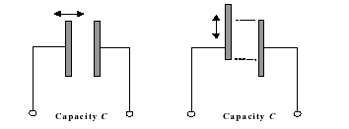 | 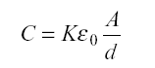

Inductive Sensor
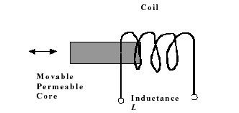

If a permeable core is inserted into an inductor, the net inductance increases. Every position of the core produces a different inductance.

Variable Reluctance

Differs from the inductive in that a moving core is used to vary the magnetic flux coupling between two or more coils, rather than changing an individual inductance. The most common and extensively used is called a linear variable differential transformer (LVDT).
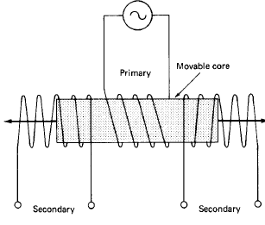

Figure : A linear variable differential transformer(LVDT) has a primary excitation coil and two series connected secondary coils with a movable core.

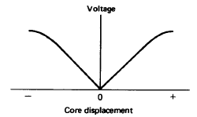

Figure : Over some range of core motion the LVDT voltage amplitude versus core displacement is very linear. This is opposition-connected secondaries.

The voltage amplitude is linear with core displacement over some range of core travel. There is a phase change as the core moves through the central location.
The signal conditioning consists circuits that perform (a) phase-sensitive detector for the direction of displacement, and (b) a level proportional to amplitude.

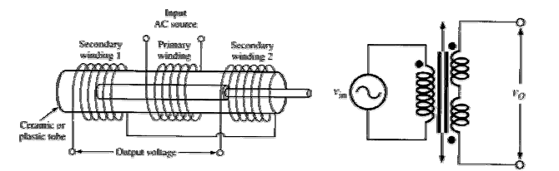

Applications :To measure linear displacement, e.g. for measuring tube lengths in a steel plant, applied in linear servomechanisms, etc.

TRANSDUCERS FOR LIGHT: LIGHT DEPENDENT RESİSTOR (LDR)

When a photon of light of a suitable wavelength falls on a semiconductor, an electron can be excited from the valence band into the conduction band. The resistance of the material then decreases. This leaves the absence of an electron in the valence band - usually referred to a positively charged 'hole'. Eventually an electron and a hole will meet and recombine, and the original resistance will be restored. There are some materials, particularly CdS or CdSe, where the decrease in resistance can be greatly amplified. An LDR usually consists of a thin, folded, strip of such material. Their response time is quite slow (typically hundreds of milliseconds).

Photodiode , Phototransistor

Sensor Time Response (dynamic char.)
The static transfer function of a process-control loop element specifies how the output is related to the input if the input is constant. An element also has a time dependence that specifies how the output changes in time when the input is changing in time. It is independent from the static transfer function. This dynamic transfer function, which is independent from the static transfer function, is often simply called the time response.

First Order Response
The simplest time response of a sensor is shown in figure below
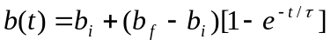
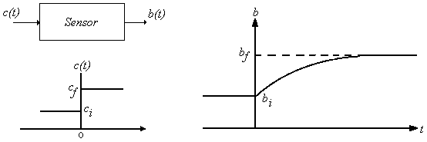
b_{i} = initial sensor output from static transfer function and initial input
b_{f} = final sensor output from static transfer function and final input
τ = sensor time constant

A sensor measures temperature linearly with a static transfer function of 33mV/ºC and has a 1.5-s time constant. Find the outout o.75s after the input changes from 20ºC to 41ºC. find the error in temperature this represents.

b_{i} = (33mV/ºC)(20ºC)
b_{i} = (660mV
b_{f} = (33mV/ºC)(41ºC)
b_{f} = 1353mV

b(0.75) =660 + (1353 – 660)[1 – e^{-0.75/1.5}]
b(0.75) = 932.7 mV
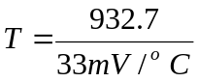T = 28.3ºC

Actuators: The other side of the coin from sensors...enable a microprocessor to modify the analog world. Examples:

- speakers that transform an electrical signal into acoustic energy (sound)
- remote control that produces an infrared signal to control stereo/TV operation
- motors: used to transform electrical signals into mechanical motion
- Relay and Selenoid.

Some definitions :

Dynamic Variable: Any physical parameters which can change either spontaneously or from external influences is a dynamic variable
Measurement: The conversion of the variable into some corresponding analog of the variable such as a pneumatic pressure, an electrical voltage or current
Sensor: (Transducer)
A device that performs the initial measurement and energy conversion of a dynamic variable into analogous electrical or pneumatic information. Further transformation or signal conditioning may be required to complete the measurement function.
Controller: Examine the measurement and determine the action.
Actuator: (Control Element) A device that exerts a direct influence on the process.
Setpoint: The value of the dynamic variable which is desired in the process
Dynamic Response: A measure of system reaction, as a function of time, in correcting transient input, or adjusting to a new set point.
Transient Response:
Description of system’s ability to recover from a sudden change in input which causes an abrupt change in the controlled variable.
Sampling: Convert an analog function of time into a sequence of binary numbers

